🔁 Types of SMS by Communication Purpose:
# Source: AI Source: Provided by: [Data Path: Persons Table -> ID Column: 1, Name_En Column: Motasem Essam] -> From: [Chatgpt (GPT‑5 Mini)] on [1/21/2026]
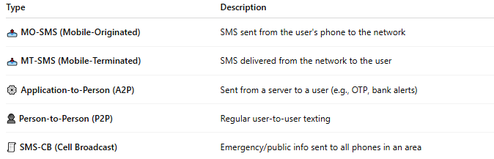

Type | Description
📤 MO-SMS (Mobile-Originated) | SMS sent from the user's phone to the network
📥 MT-SMS (Mobile-Terminated) | SMS delivered from the network to the user
⚙️ Application-to-Person (A2P) | Sent from a server to a user (e.g., OTP, bank alerts)
👤 Person-to-Person (P2P) | Regular user-to-user texting
🧾 SMS-CB (Cell Broadcast) | Emergency/public info sent to all phones in an area

